List Bluetooth devices, pick one

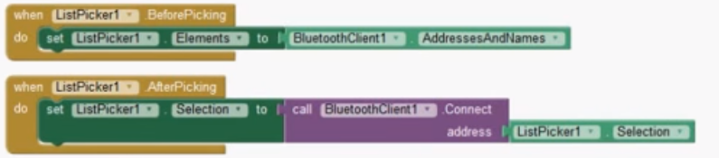

Check incoming data

